Exercise for SQL Bootcamp

Q1: List the properties for Rent and state how many?

SELECT *
FROM property_for_rent;

SELECT COUNT(Pno) AS 'no_properties'
FROM property_for_rent;

no_properties
6

Q2: List the Branches and state how many?

SELECT Count(Bno) AS no_branches
FROM branch;

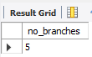

Q3: List all information about the Staff?

SELECT *
FROM staff;

Q4: List the Staff working at branch No. B5?

SELECT *
FROM staff
WHERE Bno = 'B5';

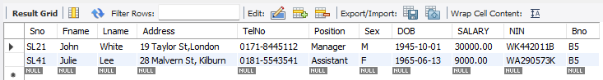

Then for B5 and B3 together

SELECT *
FROM staff
WHERE Bno IN ('B5', 'B3');

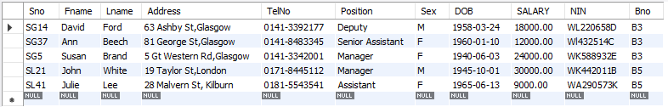

Q5: List the Staff No, the names, addresses and Telephone Numbers for all staff members?

SELECT Sno, Fname, Address, TelNo
FROM staff;

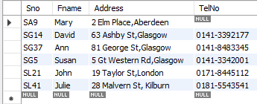

Q6: Produce the following from the Estate Agency database:

Sno Name Position
SL21 John White Manager
SG5 Susan Brand Manager

Explanation:
CONCAT(str1,str2,...)
The concat function is used to concatenate two or more string and returns concatenating string. If the arguments are numeric, they will be converted to strings before concatenating. If any of argument in the argument list is NULL, the concat function will return NULL.

SELECT Sno, CONCAT(Fname, ' ', Lname) AS Name, Position
FROM staff
WHERE Sno IN ('SL21', 'SG5')
ORDER BY Name;

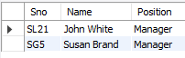

Q7: List each Staff No, Staff name (first and surname), tel no & branch no in ascending order of name?

SELECT Sno, CONCAT(Fname, ' ', Lname) AS Name, TelNo, Bno
FROM staff
ORDER BY Name ASC;

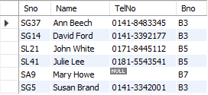

Q8: Show the staff number of the person that is responsible for property PA14.

SELECT Sno, Pno
FROM property_for_rent
WHERE Pno = 'PA14';

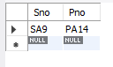

Q9: Find Owners that live in Aberdeen?

SELECT *
FROM owner
WHERE Address LIKE '%Aberdeen%';

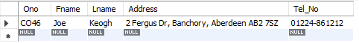

Q10: Find Owners whose first names begin with the letter ‘C’:

SELECT *
FROM owner
WHERE Fname LIKE 'C%';

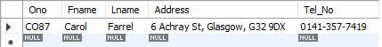

Q11: Show the following for all properties:

- Pno,
- Street,
- Rooms,
- Rent,
- Owner No
- Staff No

SELECT Pno, Street, Rooms, Rent, Ono, Sno
FROM property_for_rent;

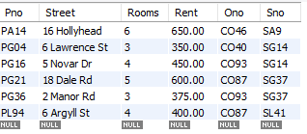

Q12: Then for property No: PG4.

SELECT Pno, Street, Rooms, Rent, Ono, Sno
FROM property_for_rent
WHERE Pno = 'PG4';

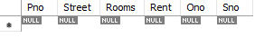

Q13: Or for owner No: CO46.

SELECT Pno, Street, Rooms, Rent, Ono, Sno
FROM property_for_rent
WHERE Pno = 'PG4'
OR Ono = 'CO46';

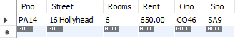

Q14: For properties that the rent is greater than 400.

SELECT Pno, Street, Rooms, Rent, Ono, Sno
FROM property_for_rent
WHERE Rent > 400;

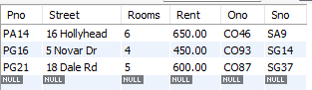

Q15: For properties that the rent is between 355 and 470.

SELECT Pno, Street, Rooms, Rent, Ono, Sno
FROM property_for_rent
WHERE Rent > 400 AND Rent < 470;

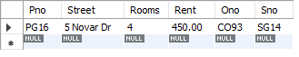
Table Setup for Estate Agency referred to in class notes:

Branch
Bno | Street | Area | City | Pcode | Tel_No | Fax_No
B5 | 22 Deer Rd | Sidcup | London | SW1 2EH | 0171-8861212 | 0171-8861214
B7 | 16 Argyll St | Dyce | Aberdeen | AB2 3SU | 01224-67125 | 01224-67111
B3 | 163 Main St | Partick | Glasgow | G11 9QX | 0141-3392178 | 0141-3394439
B4 | 32 Manse Rd | Leigh | Bristol | BS99 1NZ | 0117-9161170 | 0117-7761114
B2 | 56 Clover Dr |  | London | NW10 6EU | 0181-9631030 | 0181-4537992

Staff
Sno | Fname | Lname | Address | TelNo | Position | Sex | DOB | Salary | NIN | Bno
SL21 | John | White | 19 Taylor St,  London | 0171-8445112 | Manager | M | 1/10/45 | 30000 | WK442011B | B5
SG37 | Ann | Beech | 81 George St,  Glasgow | 0141-8483345 | Senior Assistant | F | 10/160 | 12000 | Wl432514C | B3
SG14 | David | Ford | 63 Ashby St,  Glasgow | 0141-3392177 | Deputy | M | 24/3/58 | 18000 | WL220658D | B3
SA9 | Mary | Howe | 2 Elm Place,  Aberdeen |  | Assistant | F | 19/2/70 | 9000 | WM532187D | B7
SG5 | Susan | Brand | 5 Gt Western Rd,  Glasgow | 0141-3342001 | Manager | F | 3/6/40 | 24000 | WK588932E | B3
SL41 | Julie | Lee | 28 Malvern St  Kilburn | 0181-5543541 | Assistant | F | 13/6/65 | 9000 | WA290573K | B5

PROPERTY_FOR_RENT
Pno | Street | Area | City | Pcode | Type | Rooms | Rent | Ono | Sno | Bno
PA14 | 16 Hollyhead | Dee | Aberdeen | AB7 5SU | House | 6 | 650 | CO46 | SA9 | B7
PL94 | 6 Argyll St | Kilburn | London | NW2 | Flat | 4 | 400 | CO87 | SL41 | B5
PG4 | 6 Lawrence St | Partick | Glasgow | G11 9QX | Flat | 3 | 350 | CO40 | SG14 | B3
PG36 | 2 Manor Rd |  | Glasgow | G32 4QX | Flat | 3 | 375 | CO93 | SG37 | B3
PG21 | 18 Dale Rd | Hyndland | Glasgow | G12 | House | 5 | 600 | CO87 | SG37 | B3
PG16 | 5 Novar Dr | Hyndland | Glasgow | G12 9AX | Flat | 4 | 450 | CO93 | SG14 | B3

RENTER
Rno | Fname | Lname | Address | Tel_No | Pref_Type | Max_Rent
CR76 | John | Kay | 56 High St, Putney, London, SW1 4EH | 0171-774-5632 | Flat | 425
CR56 | Aline | Stewart | 64 Fern Dr. Pollock, Glasgow, G42 OBL | 0141-848-1825 | Flat | 350
CR74 | Mike | Ritchie | 18 Tain St, Gourock., PA1G 1YQ | 01475-392178 | House | 750
CR62 | Mary | Tregear | 5 Tarbot Rd,Kidary, Aberdeen, AB9 3ST | 01224-196720 | Flat | 600

OWNER
Ono | Fname | LName | Address | Tel_No
CO46 | Joe | Keogh | 2 Fergus Dr, Banchory, Aberdeen AB2 7SZ | 01224-861212
CO87 | Carol | Farrel | 6 Achray St, Glasgow, G32 9DX | 0141-357-7419
CO40 | Tina | Murphy | 63 Well St, Shawlands, Glasgow G42 | 0141-934-1728
CO93 | Tony | Shaw | 12 Park Pl, Hillhead, Glasgow G4 OQR | 0141-225-7025

VIEWING
Rno | Pno | Date | Comment
CR56 | PA14 | 24/5/95 | Too small
CR76 | PG4 | 20/4/95 | Too remote
CR56 | PG4 | 26/5/95
CR62 | PA14 | 14/5/95 | No dining room
CR56 | PG36 | 28/4/95

